Lena Corrections

## Plot

## OI

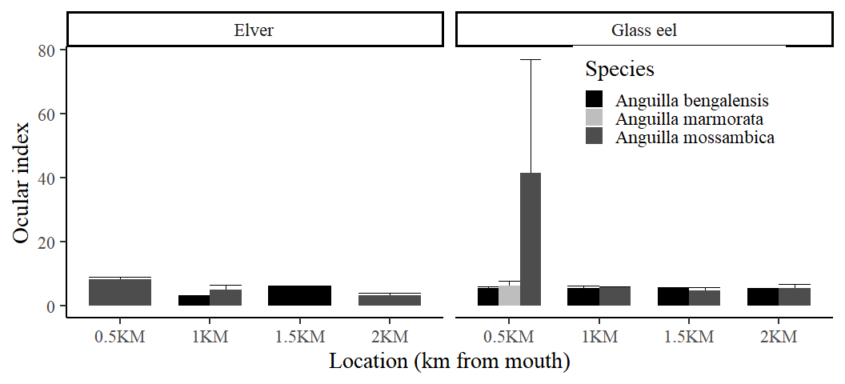

## Elongation

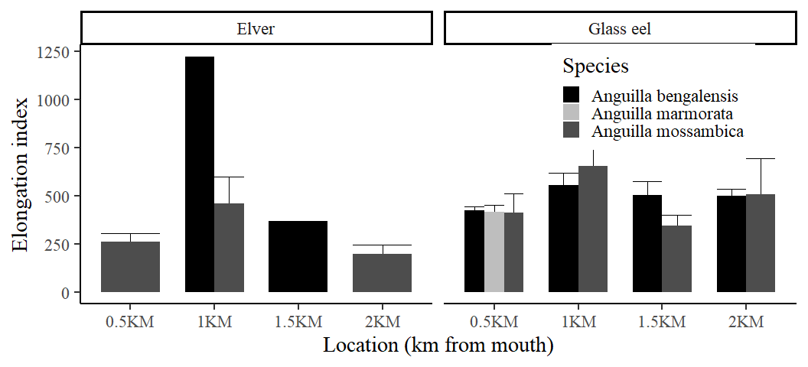

## Total lengh

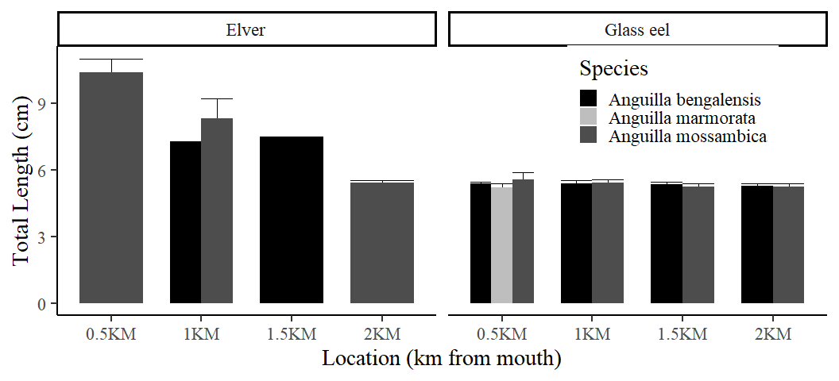

## Lunar phase

## OI

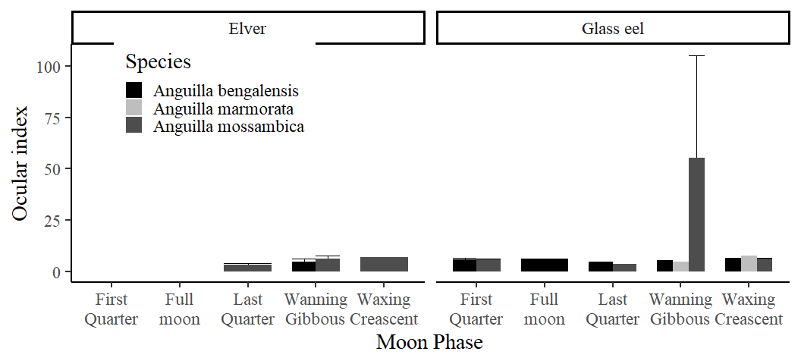

## Elongation

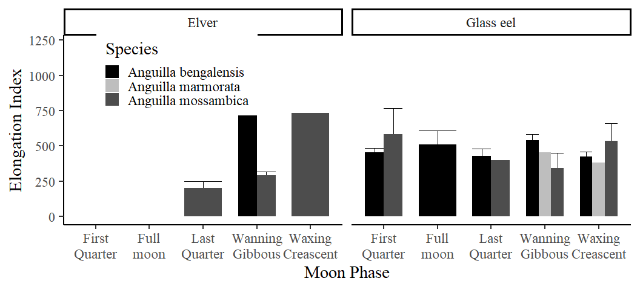

## Total lengh

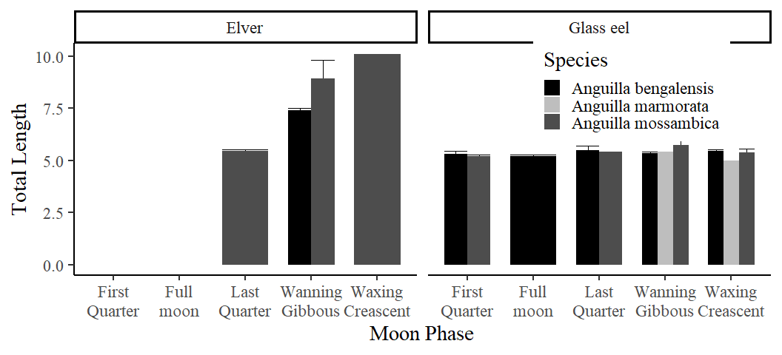

## Recruitment and phases of the moon (CPUE)

### Glass eels

| Moon Phase | Anguilla bengalensis | Anguilla mossambica | Anguilla marmorata |
| --- | --- | --- | --- |
| Wanning Gibbous | 0.67 | 0.21 | 0.04 |
| First Quarter | 0.42 | 0.17 | NA |
| Full moon | 0.42 | NA | NA |
| Last Quarter | 0.33 | 0.04 | NA |
| Waxing Creascent | 0.25 | 0.17 | 0.04 |

### Elvers

| Moon Phase | Anguilla mossambica | Anguilla bengalensis |
| --- | --- | --- |
| Wanning Gibbous | 0.17 | 0.08 |
| Last Quarter | 0.12 | NA |
| Waxing Creascent | 0.04 | NA |

## CPUE PLOT

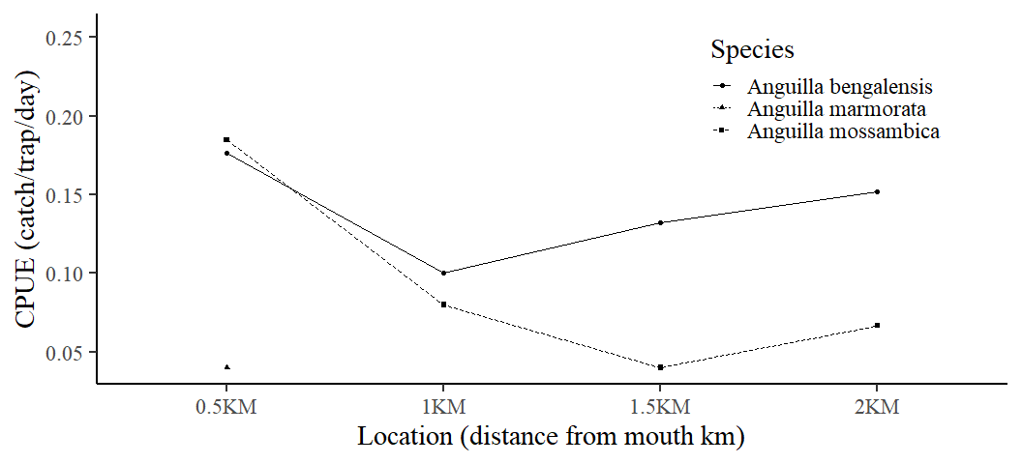

## cpue by life stage

## CPUE PLOT

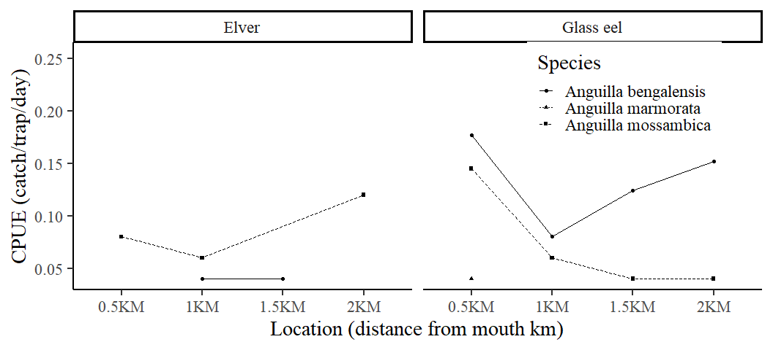

## Total Length across distances

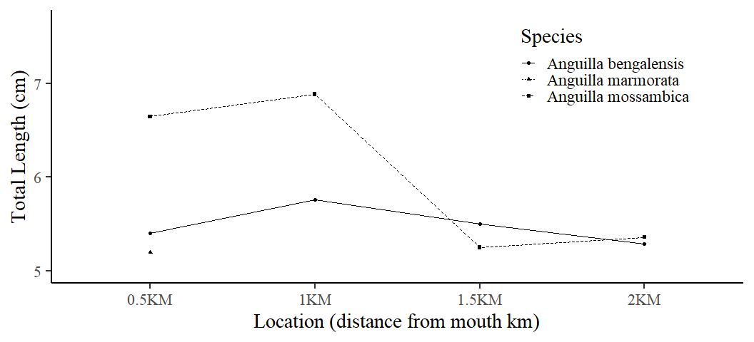

## Total Length across distances and life stage

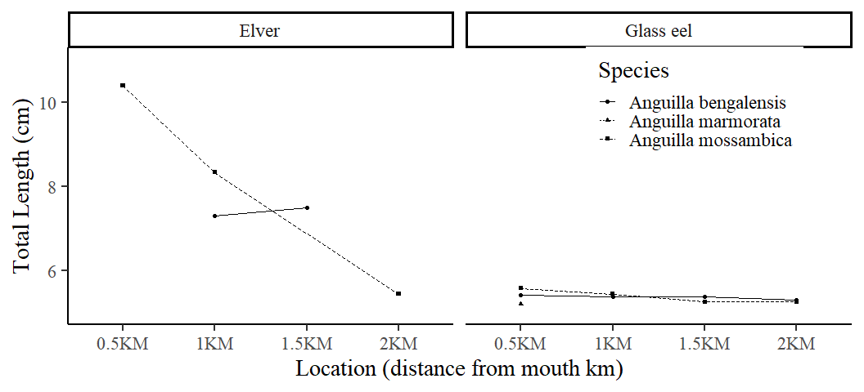

## Length

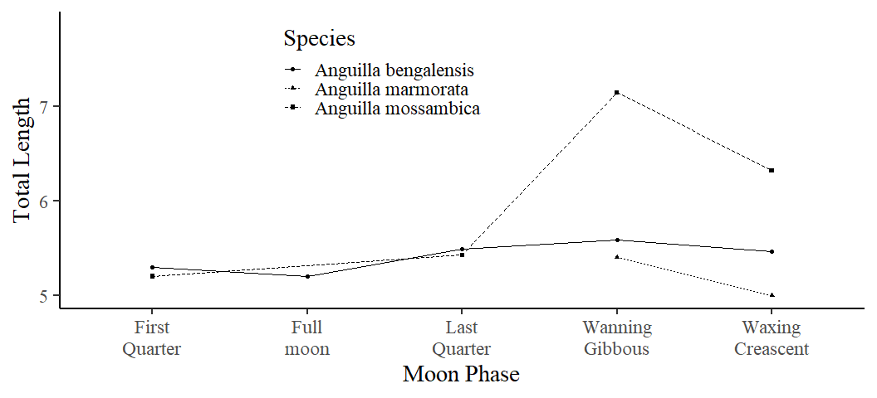

## Length by life stage

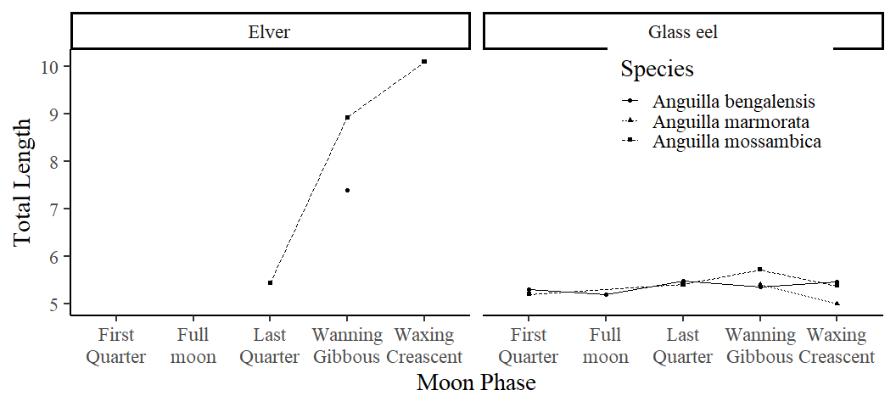

## CPUE FOR ALL SPECIES

| Species | catch | CPUE | Total Length (cm) | Weight (g) | Biomass |
| --- | --- | --- | --- | --- | --- |
| Glossogobius giuris | 926.9 | 38.62 | 14.92 | 23.23 | 21.53 |
| Oreochromis spirulus spirulus | 118.0 | 4.92 | 15.36 | 26.64 | 3.14 |
| Anguilla bengalensis | 51.0 | 2.12 | 5.55 | 5.15 | 0.26 |
| Oreochromis mossambicus | 47.0 | 1.96 | 16.33 | 15.88 | 0.75 |
| Pisonodophis boro | 45.0 | 1.88 | 108.70 | 71.80 | 3.23 |
| Scylla serrata | 37.0 | 1.54 | 10.50 | 23.06 | 0.85 |
| Bagrus docmak | 36.0 | 1.50 | 38.81 | 77.25 | 2.78 |
| Stenogobius kenyae | 25.0 | 1.04 | 69.97 | 17.32 | 0.43 |
| Planiliza alata | 24.0 | 1.00 | 4.26 | 2.67 | 0.06 |
| Anguilla mossambica | 23.0 | 0.96 | 6.52 | 5.25 | 0.12 |
| Otolithes ruber | 14.0 | 0.58 | 20.22 | 21.69 | 0.30 |
| Penaeus indicus | 5.0 | 0.21 | NaN | 536.11 | 2.68 |
| Anguilla marmorata | 2.0 | 0.08 | 5.00 | 5.10 | 0.01 |
| Barbus oxyrhynchus | 1.0 | 0.04 | 124.00 | 19.00 | 0.02 |